**Part-III – Relational Database Implementation**

* **Tables Creation.**
* **Collect data manually and create database/ Insert the values.**
* **Print out the Tables. Display the tables.**

1. create table staff(staff_id integer primary key not null,s_name char(20) unique,s_capacity integer);  
   insert into staff values(1,'cse',20);  
   insert into staff values(2,'ece',15);  
   insert into staff values(3,'eee',10);  
   insert into staff values(4,'ce',19);  
   insert into staff values(5,'me',12);

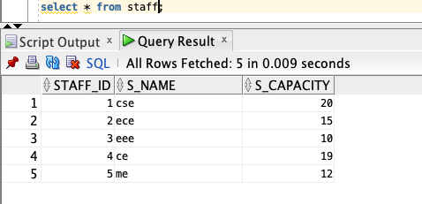

1. create table teaching_staff(t_id integer,t_sal integer,t_ssn integer,t_age integer check (t_age>18),t_name char(20),  
   primary key(t_id),  
   foreign key(t_id) references staff(staff_id));  
   insert into teaching_staff values(1,45000,23456,40,'Mahesh');  
   insert into teaching_staff values(2,60000,20054,42,'Rajshekar');  
   insert into teaching_staff values(3,80000,23656,55,'Chitambaram');  
   insert into teaching_staff values(4,65000,23496,45,'Subharao');  
   insert into teaching_staff values(5,70000,13456,50,'Rambabu');

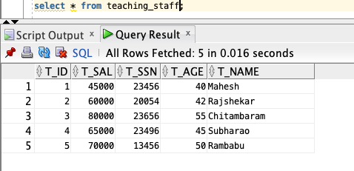

1. create table nonteaching_staff(nt_id integer,nt_sal integer,nt_ssn integer,nt_name char(20),nt_gender char(20),  
   primary key(nt_id),  
   foreign key(nt_id) references staff(staff_id));  
   insert into nonteaching_staff values(1,20000,43456,40,'Neeraj');  
   insert into nonteaching_staff values(2,25000,21456,35,'Ravi');  
   insert into nonteaching_staff values(3,30000,42456,30,'Kiran');  
   insert into nonteaching_staff values(4,45000,43456,31,'Suresh');  
   insert into nonteaching_staff values(5,40000,43556,32,'Ganesh');

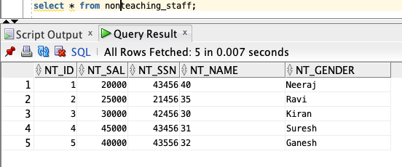

1. create table section(section_id integer primary key,section_name char(20),capacity integer,subject_name char(20));

insert into section values(602,'B3',62,'DBMS');  
 insert into section values(502,'B2',60,'DAA');  
 insert into section values(315,'B1',65,'FLAT');  
 insert into section values(601,'B4',61,'SE');  
 insert into section values(609,'B9',69,'EEE');

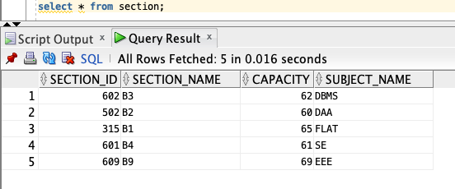

1. create table studentcanbein(s_id integer,section_id integer,  
   primary key(s_id),  
   foreign key(s_id) references student,  
   foreign key(section_id) references section);

insert into studentcanbein values(6,601);  
insert into studentcanbein values(12,602);  
insert into studentcanbein values(18,609);  
insert into studentcanbein values(50,315);  
insert into studentcanbein values(60,502);

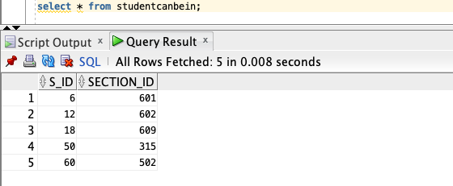

1. create table student(s_id integer primary key,s_name char(20),s_age integer,s_phone integer);

insert into student values(6,’Sai’,20,9199929981);

insert into student values(12,’Manojna’,20,9199929982);

insert into student values(18,’Abhishek’,20,9199929983);

insert into student values(50,’Kalyan’,20,9199929969);

insert into student values(60,’Vikas’,20,9199929990);

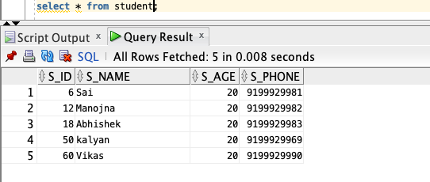

1. create table administration(adm_id integer primary key,adm_name char(20),adm_gender char(20),adm_ssn integer);  
   insert into administration values(10,'Ramesh','Male',53412);  
   insert into administration values(11,'Sunita','Female',52412);  
   insert into administration values(12,'Raju','Male',43412);  
   insert into administration values(15,'Sirisha','Female',33412);  
   insert into administration values(17,'Neeta','Female',23412);

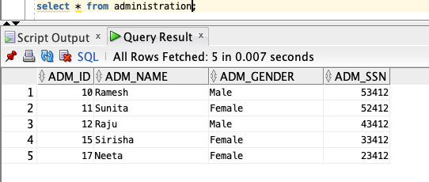

1. create table nonteaching_staffpays(nt_id integer,adm_id integer,  
   primary key(nt_id),  
   foreign key(nt_id) references nonteaching_staff,  
   foreign key(adm_id) references administration);  
   insert into nonteaching_staffpays values(1,10);  
   insert into nonteaching_staffpays values(2,11);  
   insert into nonteaching_staffpays values(3,12);  
   insert into nonteaching_staffpays values(4,15);  
   insert into nonteaching_staffpays values(5,17);

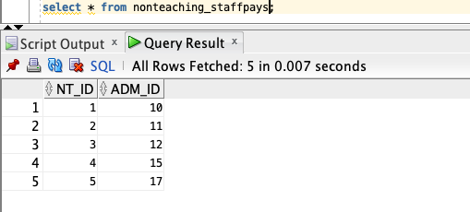

1. create table academic_department(dept_id integer primary key,dept_name char(20) unique,no_programs integer);  
   insert into academic_department values(101,'cse',20);  
   insert into academic_department values(210,'eee',10);  
   insert into academic_department values(310,'ece',5);  
   insert into academic_department values(301,'me',15);  
   insert into academic_department values(401,'ce',7);

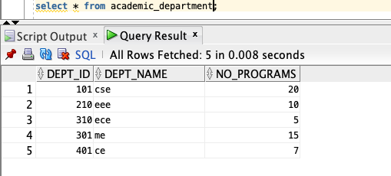

1. create table academic_departmentHOD(dept_id integer,t_id integer,since integer,  
   primary key(dept_id),  
   foreign key(dept_id) references academic_department,  
   foreign key(t_id) references teaching_staff);

insert into academic_departmentHOD values(101,1,1998);  
insert into academic_departmentHOD values(210,2,1999);  
insert into academic_departmentHOD values(310,3,1994);  
insert into academic_departmentHOD values(401,4,2000);  
insert into academic_departmentHOD values(301,5,2009);

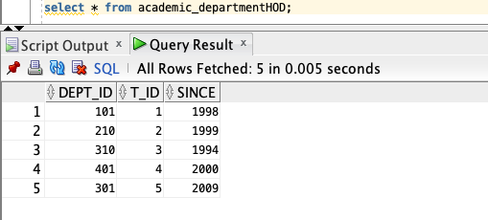

1. create table degree(degree_id integer primary key,grade integer,gpa integer,degree_name char(20));  
   insert into degree values(10,10,10,'BTech');  
   insert into degree values(11,10,10,'MTech');  
   insert into degree values(12,10,10,'BArch');  
   insert into degree values(15,10,10,'BA');  
   insert into degree values(17,10,10,'BSc');

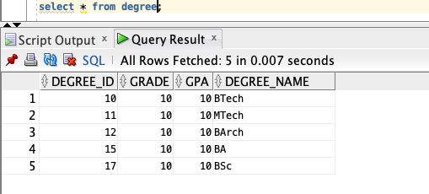

1. create table degreegives(degree_id integer,adm_id integer,  
   primary key(degree_id),  
   foreign key(degree_id) references degree,  
   foreign key(adm_id) references administration);  
   insert into degreegives values(10,10);  
   insert into degreegives values(11,17);  
   insert into degreegives values(12,15);  
   insert into degreegives values(15,12);  
   insert into degreegives values(17,11);

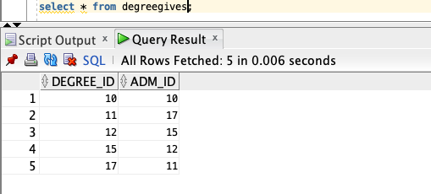

1. create table library(lib_id integer primary key,lib_capacity integer,no_ofbooks integer);

insert into library values(1,200,150);  
insert into library values(2,500,400);  
insert into library values(3,1000,786);  
insert into library values(4,2000,1500);  
insert into library values(5,700,400);

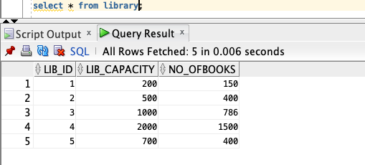

1. create table issue(issue_id integer,book_name char(20),  
   primary key(issue_id),  
   foreign key(issue_id) references library(lib_id));

insert into issue values(1,'DAA');  
 insert into issue values(2,'FLAT');  
 insert into issue values(3,'EEE');  
 insert into issue values(4,'SE');

insert into issue values(5,'EEE');

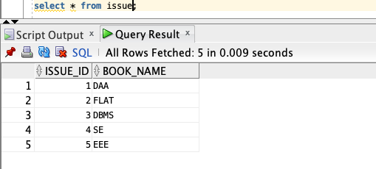

1. create table renewal(renewal_id integer,book_name char(20),  
   primary key(renewal_id),  
   foreign key(renewal_id) references library(lib_id));  
   insert into renewal values(1,'FLAT');  
   insert into renewal values(2,'DAA');  
   insert into renewal values(3,'SE');  
   insert into renewal values(4,'EEE');  
   insert into renewal values(5,'DBMS');

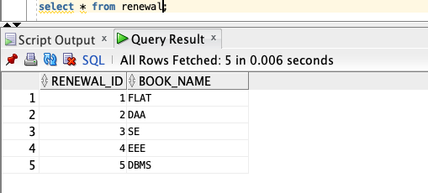

1. create table return(return_id integer,book_name char(20),  
   primary key(return_id),  
   foreign key(return_id) references library(lib_id));

insert into return values(2,'DBMS');  
insert into return values(3,'SE');  
insert into return values(4,'EEE');  
insert into return values(5,'DAA');

insert into return values(1,'FLAT');

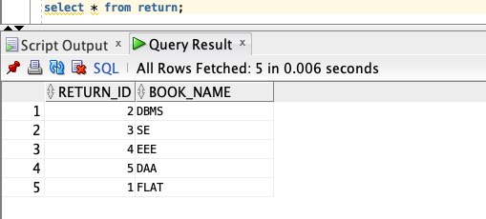

1. create table hospital(hosp_id integer primary key,capacity integer);

insert into hospital values(1,20);  
 insert into hospital values(2,25);  
 insert into hospital values(3,30);  
 insert into hospital values(4,40);  
 insert into hospital values(5,50);

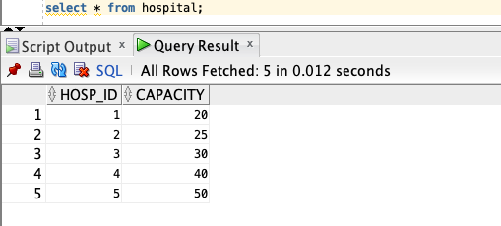

1. create table glearn(reg_no integer primary key,attendance integer,syllabus char(20),lesson_plan char(20),material char(20));

insert into glearn values(06,60,'module one','ten hours','sudarshan');  
 insert into glearn values(12,88,'module two','five hours','Ravi kant');  
 insert into glearn values(18,75,'module three','six hours','sushant');  
 insert into glearn values(50,77,'module four','eight hours','shivam');  
 insert into glearn values(60,92,'module five','nine hours','shasi');

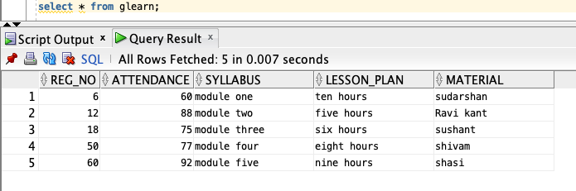

1. create table branch(branch_id integer primary key not null,branch_name char(20));

insert into branch values(101,'CSE');  
 insert into branch values(201,'ECE');  
 insert into branch values(301,'EEE');  
 insert into branch values(401,'CE');  
 insert into branch values(501,'ME');

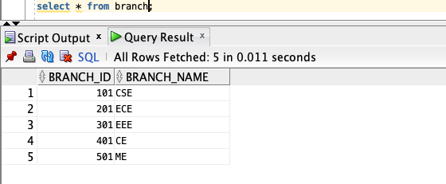

1. create table program(prog_id integer primary key,prog_name char(20),no_ofcourses integer);

insert into program values(1,'cse',7);  
 insert into program values(2,'eee',7);  
 insert into program values(3,'ece',5);  
 insert into program values(4,'me',8);  
 insert into program values(5,'ce',6);

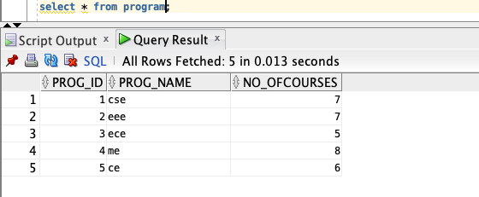

1. create table cse(cse_id integer,cse_sec char(20),  
   primary key(cse_id),  
   foreign key(cse_id) references branch(branch_id));  
   insert into cse values(111,'B');  
   insert into cse values(121,'B1');  
   insert into cse values(131,'B2');  
   insert into cse values(141,'B3');  
   insert into cse values(151,'B4');

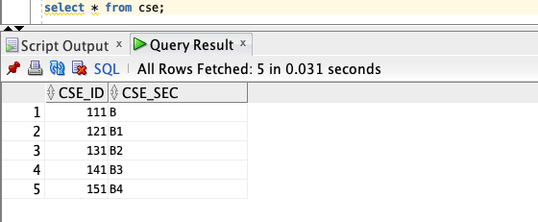

1. create table ece(ece_id integer,ece_sec char(20),  
   primary key(ece_id),  
   foreign key(ece_id) references branch(branch_id));  
   insert into ece values(211,'E1');  
   insert into ece values(221,'E2');  
   insert into ece values(231,'E3');  
   insert into ece values(241,'E4');  
   insert into ece values(251,'E5');

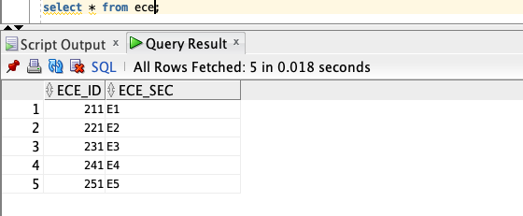

1. create table it(it_id integer,it_sec char(20),  
   primary key(it_id),  
   foreign key(it_id) references branch(branch_id));  
   insert into it values(410,’I1’);  
   insert into it values(411,’I2’);  
   insert into it values(412,'I3');  
   insert into it values(413,'I4');  
   insert into it values(414,'I5');

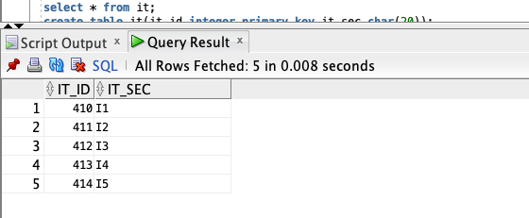

1. create table civil(civil_id integer,civil_sec char(20),  
   primary key(civil_id),  
   foreign key(civil_id) references branch(branch_id));  
   insert into civil values(421,’C5’);  
   insert into civil values(481,’C1’);  
   insert into civil values(431,’C2’);  
   insert into civil values(441,’C3’);  
   insert into civil values(451,’C4’);

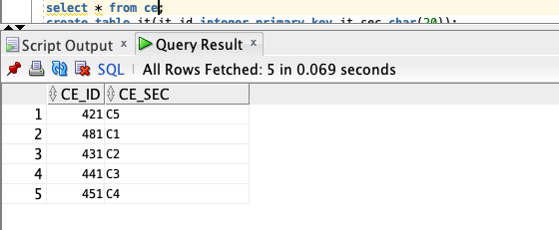

1. create table eee(eee_id integer,eee_sec char(20),  
   primary key(eee_id),  
   foreign key(eee_id) references branch(branch_id));  
   insert into eee values(321,'EE2');  
   insert into eee values(341,'EE3');  
   insert into eee values(351,'EE4');  
   insert into eee values(361,'EE5');  
   insert into eee values(311,'EE1');

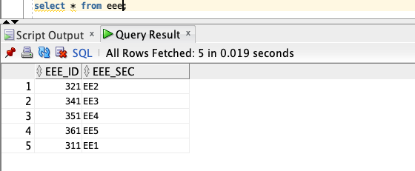

1. create table cr(cr_id integer primary key,cr_name char(20));  
   insert into cr values(60,'vikas');  
   insert into cr values(50,'varun');  
   insert into cr values(40,'raj');  
   insert into cr values(30,'tarun');  
   insert into cr values(20,'manoj');

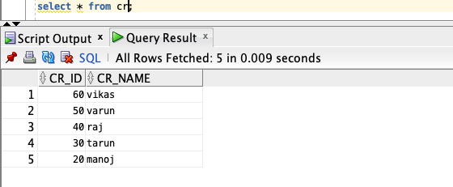

1. create table hascr(cr_id,section_id integer,  
   primary key(section_id),  
   foreign key(section_id) references section,  
   foreign key(cr_id) references cr);  
   Insert into hascr values(60,'601');  
   insert into hascr values(50,'602');  
   insert into hascr values(40,'609');  
   insert into hascr values(30,'315');  
   insert into hascr values(20,'502');

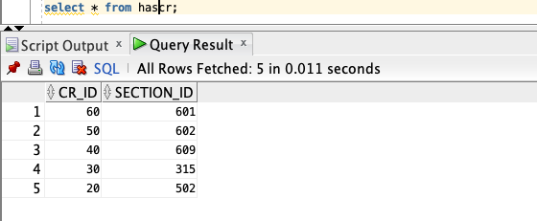

1. create table canhelp(t_id integer,s_id integer,  
   primary key(t_id,s_id),  
   foreign key(t_id) references teaching_staff,  
   foreign key(s_id) references student);  
   insert into canhelp values(1,6);  
   insert into canhelp values(2,12);  
   insert into canhelp values(3,18);  
   insert into canhelp values(4,50);  
   insert into canhelp values(5,60);

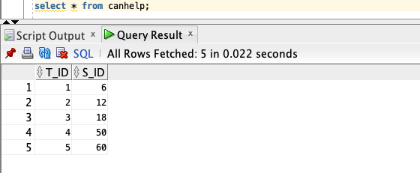

1. create table teaches(t_id integer,section_id integer,  
   primary key(t_id,section_id),  
   foreign key(t_id) references teaching_staff,  
   foreign key(section_id) references section);  
   insert into teaches values(1,602);  
   insert into teaches values(2,601);  
   insert into teaches values(3,315);  
   insert into teaches values(4,502);  
   insert into teaches values(5,609);

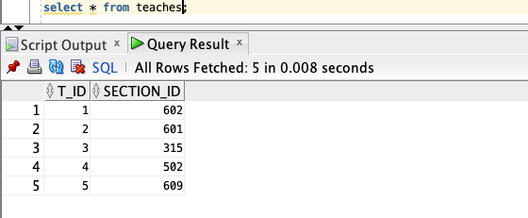

1. create table worksin(t_id integer,dept_id integer,since integer,  
   primary key(t_id,dept_id),  
   foreign key(t_id) references teaching_staff,  
   foreign key(dept_id) references academic_department);  
   insert into worksin values(1,101,1997);  
   insert into worksin values(2,210,1999);  
   insert into worksin values(3,310,2011);  
   insert into worksin values(4,401,2012);  
   insert into worksin values(5,301,2003);

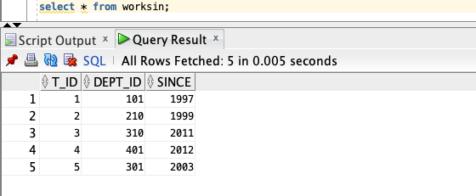

1. create table teaching_staffpays(t_id integer,adm_id integer,  
   primary key(t_id),  
   foreign key(t_id) references staff(staff_id));  
   insert into teaching_staffpays values(1,10);  
   insert into teaching_staffpays values(2,11);  
   insert into teaching_staffpays values(3,12);  
   insert into teaching_staffpays values(4,15);  
   insert into teaching_staffpays values(5,17);

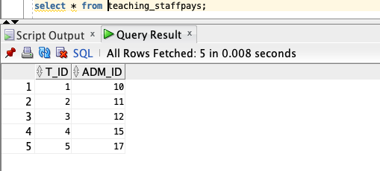

1. create table studentcanobtain(degree_id integer,s_id integer,  
   primary key(s_id),  
   foreign key(s_id) references student,  
   foreign key(degree_id) references degree);  
   insert into studentcanobtain values(10,6);  
   insert into studentcanobtain values(11,12);  
   insert into studentcanobtain values(12,18);  
   insert into studentcanobtain values(15,50);  
   insert into studentcanobtain values(17,60);

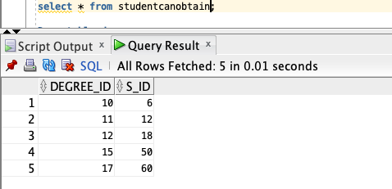

1. create table enrolls(adm_id integer,s_id integer,  
   primary key(adm_id,s_id),  
   foreign key(adm_id) references administration,  
   foreign key(s_id) references student);  
   insert into enrolls values(10,6);  
   insert into enrolls values(11,60);  
   insert into enrolls values(12,18);  
   insert into enrolls values(15,12);  
   insert into enrolls values(17,50);

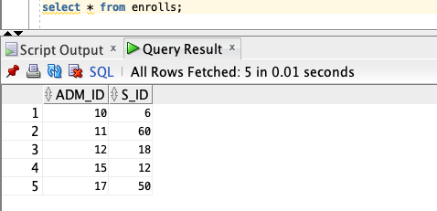

1. create table canaccess(lib_id integer,s_id integer,  
   primary key(lib_id,s_id),  
   foreign key(lib_id) references library,  
   foreign key(s_id) references student);  
   insert into canaccess values(1,12);  
   insert into canaccess values(2,60);  
   insert into canaccess values(3,6);  
   insert into canaccess values(4,18);  
   insert into canaccess values(5,50);

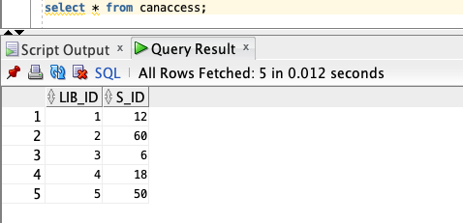

1. create table canaccess1(reg_no integer,s_id integer,  
   primary key(reg_no,s_id),  
   foreign key(reg_no) references glearn,  
   foreign key(s_id) references student);  
   insert into canaccess1 values(6,12);  
   insert into canaccess1 values(12,60);  
   insert into canaccess1 values(18,50);  
   insert into canaccess1 values(50,18);  
   insert into canaccess1 values(60,6);

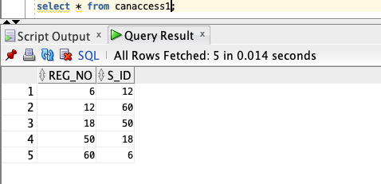

1. create table canaccess2(hosp_id integer,s_id integer,  
   primary key(hosp_id,s_id),  
   foreign key(hosp_id) references hospital,  
   foreign key(s_id) references student);  
   insert into canaccess2 values(01,12);  
   insert into canaccess2 values(02,6);  
   insert into canaccess2 values(03,18);  
   insert into canaccess2 values(04,50);  
   insert into canaccess2 values(05,60);

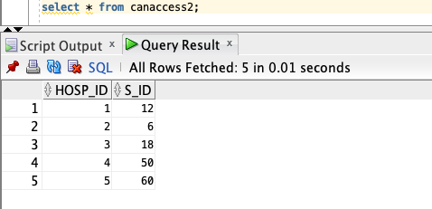

1. create table studentenrollsin(s_id integer,branch_id integer,  
   primary key(s_id),  
   foreign key(s_id) references student,  
   foreign key(branch_id) references branch);  
   insert into studentenrollsin values(06,101);  
   insert into studentenrollsin values(12,201);  
   insert into studentenrollsin values(18,301);  
   insert into studentenrollsin values(50,401);  
   insert into studentenrollsin values(60,501);

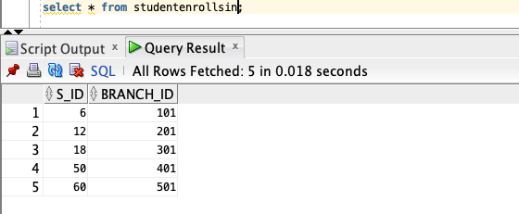

1. create table branchinstructs(dept_id integer,branch_id integer,  
   primary key(branch_id),  
   foreign key(branch_id) references branch,  
   foreign key(dept_id) references academic_department);  
   insert into branchinstructs values(101,501);  
   insert into branchinstructs values(301,401);  
   insert into branchinstructs values(401,301);  
   insert into branchinstructs values(210,201);  
   insert into branchinstructs values(310,101);

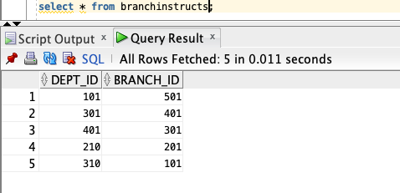

1. create table offers(prog_id integer,branch_id integer,  
   primary key(prog_id,branch_id),  
   foreign key(prog_id) references program,  
   foreign key(branch_id) references branch);

insert into offers values(1,501);  
 insert into offers values(2,401);  
 insert into offers values(3,301);  
 insert into offers values(4,101);  
 insert into offers values(5,201);

